**PROOF OF BUG**

* Verify that the user cannot add more than the available inventory of the product. Add 5 product or 5000 products. User not getting the error message and add to cart option is not updating while selecting quantity as 5.  
   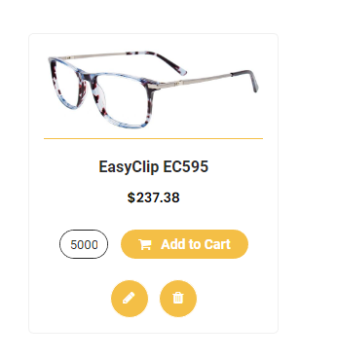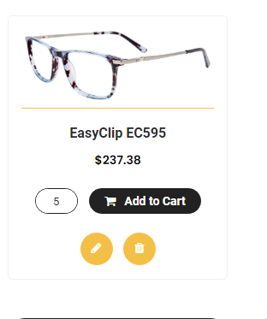 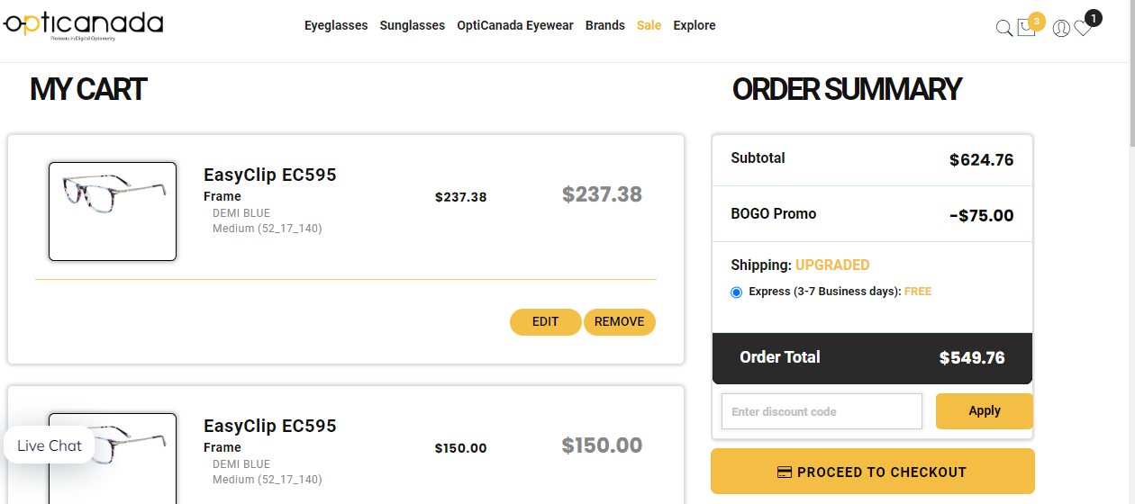

2. Sale tab colour is already changed



3. Due to live chat button, PRIVACY POLICY and TREMS OF USE is not clicking, users have to scroll up little bit.

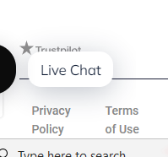

4. Account navigation header is not proper underlined.



4. Mouse hover cursor is not changing in SHOP BY FACE category.

